**Natural Language Processing**

Project Report On

Keyboard Next Word Prediction

Department of Computer Science and Engineering

The NorthCap University, Gurugram

Name: Khushal Yadav

Section: AIML-C(AL-5)

Roll No.: 21CSU188

ACKNOWLEDGEMENT

I extend my deepest gratitude to those whose support and guidance have been invaluable in the completion of this project.

I am especially grateful to **Dr Srishti Sharma**, whose expertise, encouragement, and constructive feedback guided this work from inception to completion. Her insights into Natural Language Processing and machine learning were crucial in navigating the challenges of model implementation and evaluation.

I am equally grateful to **The NorthCap University**, where access to a collaborative environment and advanced resources has fostered not only the technical achievements of this project but also the spirit of innovation that underpins it.

This project is as much a reflection of those who have supported and guided me as it is my own effort, and for that, I am sincerely thankful.

Khushal Yadav

Date: 14 November 2024

ABSTRACT

Next Word Prediction is a vital component in applications like predictive text input, search engines, and virtual assistants, aimed at enhancing user experience by suggesting contextually relevant words in real time. This project explores the effectiveness of **Long Short-Term Memory (LSTM)** and **DistilBERT** models for next-word prediction, comparing the strengths of sequential and transformer-based models in natural language processing tasks.

Using a dataset derived from **Sherlock Holmes stories**, the project involves (1) preprocessing the text, (2) training an LSTM model for sequential next-word prediction, and (3) implementing DistilBERT, a transformer-based model optimized for masked language modeling. Each model was evaluated on its ability to generate coherent predictions while retaining contextual accuracy.

Results indicate that, while LSTM performs well on short sequential patterns, DistilBERT achieves superior accuracy in capturing complex language relationships over longer contexts. DistilBERT’s self-attention mechanism allows for more contextually aware predictions, demonstrating the value of transformer models for applications demanding higher accuracy and adaptability.

This study concludes that transformer models like DistilBERT are preferable for advanced NLP tasks, showcasing their potential to enhance predictive text systems. Future work could explore further model optimizations or hybrid approaches to enhance prediction quality and efficiency.

CONTENTS

|  |  |
| --- | --- |
| Topic | Page |
| Software Requirements | 5 |
| Introduction | 7 |
| Survey Of Domain | 8 |
| Project Implementation and My Contributions | 10 |
| Code | 13 |
| Conclusion | 17 |
| References | 18 |

SOFTWARE REQUIREMENTS

**1. Operating System**

* **Platform**: The project is compatible with major operating systems such as Windows, macOS, and Linux.
* **Supported OS**: Any system supporting Python 3.x and Jupyter Notebooks/Google Colab.

**2. Programming Language**

* **Python 3.x**: The project leverages Python for data processing, machine learning, and model training. Python is chosen due to its extensive libraries in the fields of NLP and deep learning.

**3. Development Environment**

* **Google Colab**: A cloud-based development environment, ideal for training deep learning models with free access to GPUs. It supports Jupyter notebooks and simplifies the setup of machine learning tasks.
* **Jupyter Notebook**: An alternative for local development, providing an interactive environment for code and data visualization.

**4. Required Libraries**

* **TensorFlow 2.x**: For implementing and training the LSTM (Long Short-Term Memory) model used for next-word prediction.
* **Keras**: A high-level API built on TensorFlow, which simplifies model creation and training.
* **pandas**: For data manipulation, including loading and cleaning the .csv dataset.
* **NumPy**: Essential for handling arrays and numerical operations during data preprocessing.
* **Matplotlib/Seaborn**: Used for visualizing the data and performance metrics of the model.
* **scikit-learn**: To aid in splitting the dataset and evaluating the model.
* **NLTK/SpaCy**: For text preprocessing, such as tokenization, stop word removal, and stemming.

**5. Dataset**

* **Dataset Type**: A .csv file sourced from Kaggle, containing a large corpus of text data for training the predictive model.
* **Size**: The dataset must be large enough to train the LSTM model effectively, typically in the range of thousands to millions of words.

**6. Hardware Requirements**

* **Processor**: Minimum Intel Core i5 or equivalent. Higher processors (i7 or better) will improve performance.
* **RAM**: A minimum of 8 GB RAM; 16 GB or more is preferred for smoother training, especially with large datasets.
* **GPU**: A dedicated GPU (preferably NVIDIA) for faster training. Google Colab provides free access to GPUs, which is ideal for this project.

INTRODUCTION

Next Word Prediction is a critical feature in applications like predictive text and virtual assistants, aiming to enhance user experience by suggesting contextually relevant words in real time. This project investigates Next Word Prediction using two machine learning models: Long Short-Term Memory (LSTM) and DistilBERT, each offering unique strengths in understanding language context.

LSTM networks have been widely used for sequential data processing, as they capture dependencies across words in a sentence. However, their effectiveness can be limited by sequence length, as they struggle with long-range context. In contrast, transformer-based models like DistilBERT use self-attention mechanisms to handle entire sequences simultaneously, making them more efficient at retaining context over longer texts.

This project uses textual data from Sherlock Holmes stories to compare the performance of LSTM and DistilBERT in next-word prediction. By analyzing prediction accuracy, context retention, and computational efficiency, this study aims to identify the strengths and limitations of each model, providing insights into their suitability for NLP applications where accurate, context-aware predictions are essential.

Survey Of Domain

The concept of "Next Word Prediction" has been extensively explored in the field of Natural Language Processing (NLP). It is widely applied in real-world applications such as predictive keyboards, search engines, chatbots, and virtual assistants. Several researchers and organizations have contributed significantly to this domain:

**1. Google’s Smart Compose**

* **Overview**: Google has implemented advanced next-word prediction models in its "Smart Compose" feature for Gmail and Google Docs. These models leverage deep learning architectures like Recurrent Neural Networks (RNNs) and Transformer-based models such as BERT.
* **Methodology**: The system uses pre-trained models fine-tuned on vast datasets of user emails and documents, ensuring high accuracy and contextual relevance.

**2. Apple’s QuickType Keyboard**

* **Overview**: Apple’s QuickType keyboard provides predictive text suggestions based on the user’s typing habits. It uses NLP techniques combined with on-device machine learning to ensure privacy and real-time predictions.
* **Methodology**: It employs probabilistic language models to predict the next word while considering contextual word sequences.

**3. Microsoft’s SwiftKey**

* **Overview**: SwiftKey keyboard employs predictive text and autocorrect features, improving over time based on user behavior. It integrates deep learning and sequence-to-sequence models to enhance user experience.
* **Methodology**: SwiftKey uses neural networks like LSTMs and GRUs to process and learn patterns from large datasets of text input.

**4. OpenAI’s GPT Models**

* **Overview**: OpenAI’s Generative Pre-trained Transformers (GPT) models, particularly GPT-3 and GPT-4, have set benchmarks in next-word prediction tasks. They are used in various text generation and completion applications.
* **Methodology**: GPT models are trained on massive text corpora using the Transformer architecture, which allows them to handle complex dependencies in language efficiently.

**5. Academic Research**

* **Paper by Sundermeyer et al. (2012)**: *"LSTM Neural Networks for Language Modeling"* explored using LSTM networks for predictive text tasks, showcasing their ability to capture long-term dependencies.
* **Paper by Mikolov et al. (2010)**: *"Recurrent Neural Network-based Language Model"* introduced RNNs for language modeling, laying the groundwork for next-word prediction applications.

Project Implementation and My Contributions

This project involved the implementation, experimentation, and comparison of **LSTM** and **DistilBERT** models for next-word prediction. The key steps and contributions are outlined below:

**1. Dataset Collection and Preprocessing**

* Collected a **Sherlock Holmes stories dataset**, a rich source of literary text with diverse contextual patterns.
* Preprocessed the text by:
  + Removing special characters and punctuations using regular expressions.
  + Converting all text to lowercase for uniformity.
  + Splitting the text into sentences to ensure meaningful input sequences.

**2. Implementation of LSTM-Based Next Word Prediction**

* Designed and trained an **LSTM model** for next-word prediction:
  + Tokenized the input text using Keras’s Tokenizer.
  + Created n-gram sequences to train the model on sequential data patterns.
  + Padded sequences to ensure consistent input size for the model.
  + Defined a neural network architecture with:
    - An **Embedding layer** to convert words into dense vectors.
    - An **LSTM layer** to capture sequential dependencies.
    - A **Dense layer** with a softmax activation function for predicting probabilities of the next word.
  + Compiled and trained the model using categorical cross-entropy as the loss function and Adam optimizer.
* Evaluated the LSTM model’s performance in predicting next words based on various seed texts.

**3. Implementation of DistilBERT for Next Word Prediction**

* Utilized **Hugging Face's transformers library** to implement DistilBERT:
  + Loaded the pre-trained DistilBERT model and its tokenizer for Masked Language Modeling (MLM).
  + Encoded input text with a [MASK] token to predict the next word.
  + Generated predictions using the model’s logits, applying:
    - **Temperature scaling** for better diversity.
    - **Top-k sampling** to ensure contextually relevant words.
  + Applied filtering to exclude punctuation and repetitive words for improved prediction quality.
* Compared DistilBERT’s predictions with those of the LSTM model on the same dataset and seed texts.

**4. Comparison of Models**

* Analyzed both models on parameters such as:
  + **Prediction accuracy**: DistilBERT demonstrated superior context retention.
  + **Computational efficiency**: DistilBERT required higher computational resources compared to the simpler LSTM.
  + **Relevance of predictions**: DistilBERT provided more coherent and contextually aware predictions, particularly for complex sentences.
* Documented the strengths and limitations of each approach.

**5. Project Implementation and Evaluation**

* Designed an evaluation framework to test the models on multiple seed texts.
* Addressed issues such as repetitive word predictions in DistilBERT by implementing **repetition tracking** and **word diversity filters**.
* Summarized insights into the suitability of LSTM and transformer-based models for modern NLP applications.

CODE:

* 1. Using LSTM

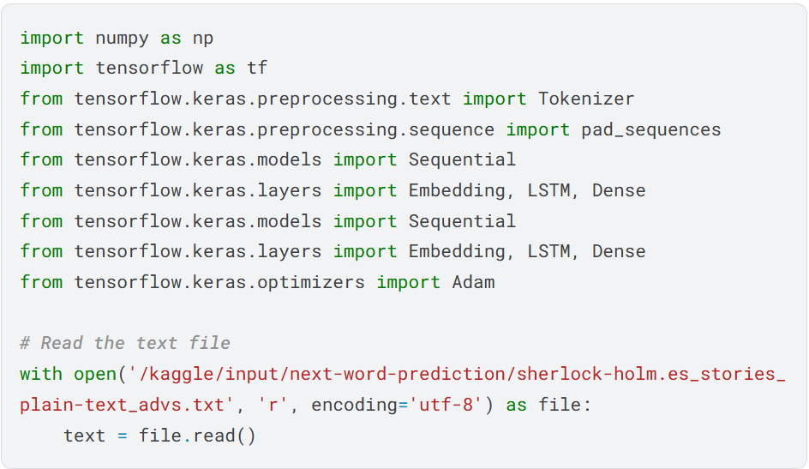

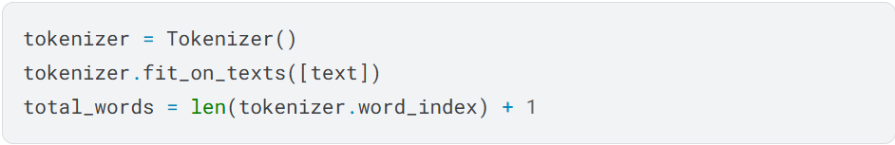

* 1. Using Distil Bert



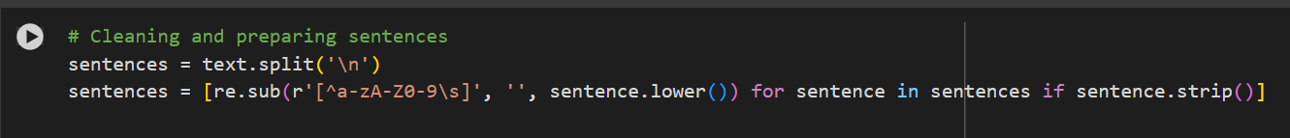

CONCLUSION

The project successfully explored and compared two distinct approaches to **Next Word Prediction**: the traditional **Long Short-Term Memory (LSTM)** model and the transformer-based **DistilBERT** model. By leveraging a textual dataset from Sherlock Holmes stories, both models were implemented, evaluated, and analyzed for their ability to generate contextually relevant predictions.

The LSTM model demonstrated solid performance for sequential data processing and handled short-term dependencies effectively. However, it struggled with longer contexts, resulting in limited accuracy for complex text. In contrast, DistilBERT’s self-attention mechanism enabled it to capture broader relationships across words, offering superior context retention and prediction quality. This highlights the significant advantages of transformer-based models for tasks requiring deeper understanding of language structures.

The project findings underline that while LSTM remains a reliable choice for simpler NLP tasks with lower computational requirements, modern transformer models like DistilBERT are better suited for applications requiring high accuracy, scalability, and adaptability. Future work could focus on optimizing transformer models further or integrating hybrid approaches to combine the strengths of both methodologies.

In conclusion, this project contributes valuable insights into the comparative performance of LSTM and DistilBERT for next-word prediction, demonstrating the transformative potential of transformer architectures in advancing NLP applications.

REFERENCES

1. **Sherlock Holmes Dataset**:
   * Arthur Conan Doyle's *Sherlock Holmes Stories*. Public domain dataset accessed from [Project Gutenberg](https://www.gutenberg.org/).
2. **LSTM Model and Applications**:
   * Hochreiter, S., & Schmidhuber, J. (1997). *Long Short-Term Memory*. Neural Computation, 9(8), 1735–1780.  
     DOI: https://doi.org/10.1162/neco.1997.9.8.1735
3. **DistilBERT and Hugging Face Library**:
   * Hugging Face. (2020). *Transformers: State-of-the-Art Natural Language Processing for TensorFlow and PyTorch*.  
     GitHub Repository: <https://github.com/huggingface/transformers>
4. **Masked Language Modeling with DistilBERT**:
   * Sanh, V., Debut, L., Chaumond, J., & Wolf, T. (2020). *DistilBERT, a distilled version of BERT: Smaller, faster, cheaper and lighter*.  
     Preprint available at <https://arxiv.org/abs/1910.01108>
5. **Keras Documentation**:
   * Keras Team. (2023). *Keras Sequential API Documentation*. TensorFlow.  
     URL: https://keras.io/api/models/sequential/
6. **Natural Language Processing Concepts**:
   * Jurafsky, D., & Martin, J. H. (2021). *Speech and Language Processing* (3rd ed.). Pearson.
7. **Python Regular Expressions**:
   * Python Software Foundation. *Python re Module Documentation*.  
     URL: <https://docs.python.org/3/library/re.html>
8. **TensorFlow Documentation**:
   * TensorFlow Team. (2023). *TensorFlow Core Documentation*.  
     URL: <https://www.tensorflow.org/>